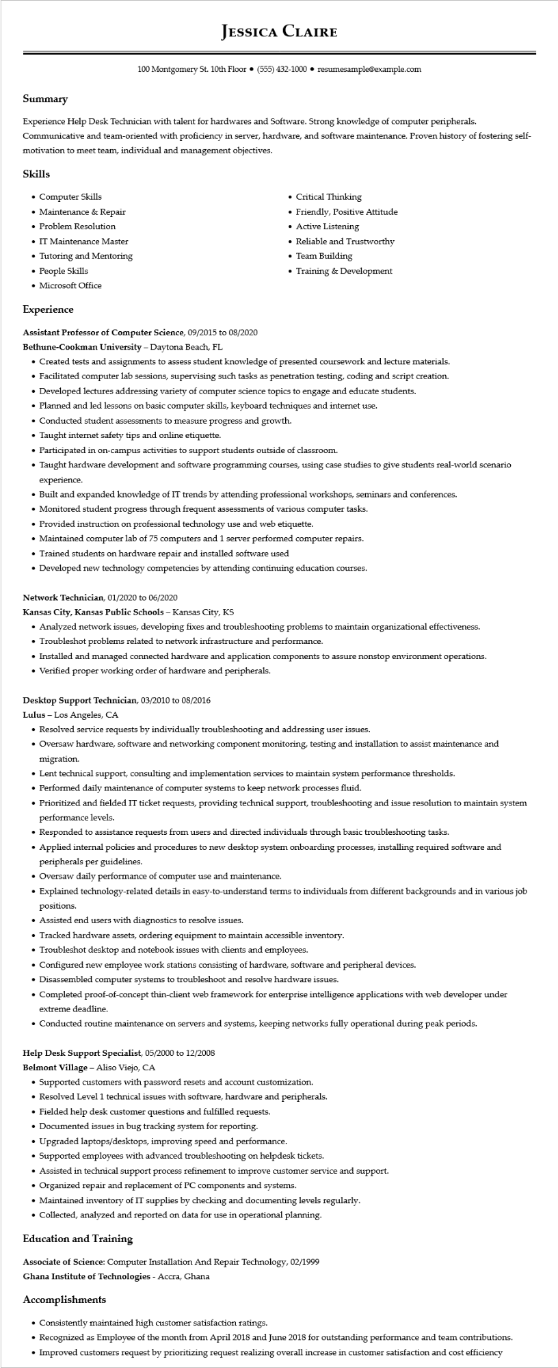
JESSICA CLAIRE
100 Montgomery St. 10th Floor ⚫ (555) 432-1000⚫ resumesample@example.com
Summary
Experience Help Desk Technician with talent for hardwares and Software. Strong knowledge of computer peripherals. Communicative and team-oriented with proficiency in server, hardware, and software maintenance. Proven history of fostering self- motivation to meet team, individual and management objectives.
Skills
• Computer Skills
• Maintenance & Repair
• Problem Resolution
• IT Maintenance Master
• Tutoring and Mentoring • People Skills
• Microsoft Office
Experience
Assistant Professor of Computer Science, 09/2015 to 08/2020
Bethune-Cookman University - Daytona Beach, FL
• Critical Thinking
• Friendly, Positive Attitude
• Active Listening
• Reliable and Trustworthy
• Team Building
• Training & Development
• Created tests and assignments to assess student knowledge of presented coursework and lecture materials.
• Facilitated computer lab sessions, supervising such tasks as penetration testing, coding and script creation.
• Developed lectures addressing variety of computer science topics to engage and educate students.
• Planned and led lessons on basic computer skills, keyboard techniques and internet use.
• Conducted student assessments to measure progress and growth.
• Taught internet safety tips and online etiquette.
• Participated in on-campus activities to support students outside of classroom.
• Taught hardware development and software programming courses, using case studies to give students real-world scenario experience.
• Built and expanded knowledge of IT trends by attending professional workshops, seminars and conferences.
• Monitored student progress through frequent assessments of various computer tasks.
• Provided instruction on professional technology use and web etiquette.
• Maintained computer lab of 75 computers and 1 server performed computer repairs.
• Trained students on hardware repair and installed software used
• Developed new technology competencies by attending continuing education courses.
Network Technician, 01/2020 to 06/2020
Kansas City, Kansas Public Schools - Kansas City, KS
• Analyzed network issues, developing fixes and troubleshooting problems to maintain organizational effectiveness.
• Troubleshot problems related to network infrastructure and performance.
• Installed and managed connected hardware and application components to assure nonstop environment operations.
• Verified proper working order of hardware and peripherals.
Desktop Support Technician, 03/2010 to 08/2016
Lulus - Los Angeles, CA
• Resolved service requests by individually troubleshooting and addressing user issues.
• Oversaw hardware, software and networking component monitoring, testing and installation to assist maintenance and migration.
• Lent technical support, consulting and implementation services to maintain system performance thresholds.
• Performed daily maintenance of computer systems to keep network processes fluid.
• Prioritized and fielded IT ticket requests, providing technical support, troubleshooting and issue resolution to maintain system performance levels.
• Responded to assistance requests from users and directed individuals through basic troubleshooting tasks.
• Applied internal policies and procedures to new desktop system onboarding processes, installing required software and peripherals per guidelines.
• Oversaw daily performance of computer use and maintenance.
• Explained technology-related details in easy-to-understand terms to individuals from different backgrounds and in various job positions.
• Assisted end users with diagnostics to resolve issues.
• Tracked hardware assets, ordering equipment to maintain accessible inventory.
• Troubleshot desktop and notebook issues with clients and employees.
Configured new employee work stations consisting of hardware, software and peripheral devices.
• Disassembled computer systems to troubleshoot and resolve hardware issues.
• Completed proof-of-concept thin-client web framework for enterprise intelligence applications with web developer under extreme deadline.
• Conducted routine maintenance on servers and systems, keeping networks fully operational during peak periods.
Help Desk Support Specialist, 05/2000 to 12/2008
Belmont Village - Aliso Viejo, CA
• Supported customers with password resets and account customization.
• Resolved Level 1 technical issues with software, hardware and peripherals.
• Fielded help desk customer questions and fulfilled requests.
• Documented issues in bug tracking system for reporting.
·
Upgraded laptops/desktops, improving speed and performance.
• Supported employees with advanced troubleshooting on helpdesk tickets.
• Assisted in technical support process refinement to improve customer service and support.
• Organized repair and replacement of PC components and systems.
• Maintained inventory of IT supplies by checking and documenting levels regularly.
• Collected, analyzed and reported on data for use in operational planning.
Education and Training
Associate of Science: Computer Installation And Repair Technology, 02/1999
Ghana Institute of Technologies - Accra, Ghana
Accomplishments
• Consistently maintained high customer satisfaction ratings.
• Recognized as Employee of the month from April 2018 and June 2018 for outstanding performance and team contributions.
• Improved customers request by prioritizing request realizing overall increase in customer satisfaction and cost efficiency

